

Project 1

<Blackjack>



CSC-5 47472

Name: Kuldeep Singh

Date: 11/05/17

**Introduction**

Title: Blackjack

Blackjack, also known as twenty-one, is a card game which is mostly played in casinos for banking money. Blackjack uses the classic 52 card deck. The goal of the game is between the player(s) and the dealer who are competing against each other to get, or get closest, to the number 21. Both the player and dealer are given 2 cards: one face up and one face down. If they believe the cards they have aren’t close enough to 21, they can ask for a “hit,” which means they would like another card. If the player exceeds the number 21 they “bust,” which causes them to automatically lose the game.

The face, or suit, cards (Ace, Jack, Queen, and King) are all considered to have the value of 10, except the Ace card can be either 11 or 1; whichever works the best with your hand.

Because of how easy the game is to learn and the quick pace of it, many people play this at casinos to test their luck on Blackjack.

**Summary**

Project Size: 183 lines

Number of Variables: About 20

Methods: 2

For this project, I used the concepts I learned in class and the first five chapters of the Gaddis and Savitch book. The projects only took me a few days to complete, but it was extremely difficult for me to do, since it was my first major programming project.

Within the process of completing the project, I had many problems.

The random number generator wasn’t generating random numbers; the sequence of numbers was the same every time I ran the program. For this I went to [www.cplusplus.com](http://www.cplusplus.com) to know how to use the srand function and the ctime library.

I also kept leaving out some important details of the code, like not putting an output statement for a looping function.

Although the project is far from perfect, I am very happy with the outcome.

**Description**

The objective of the game is to beat the dealer and other participants, by getting their card count to, or close to 21, without exceeding it.

**Flow Chart**

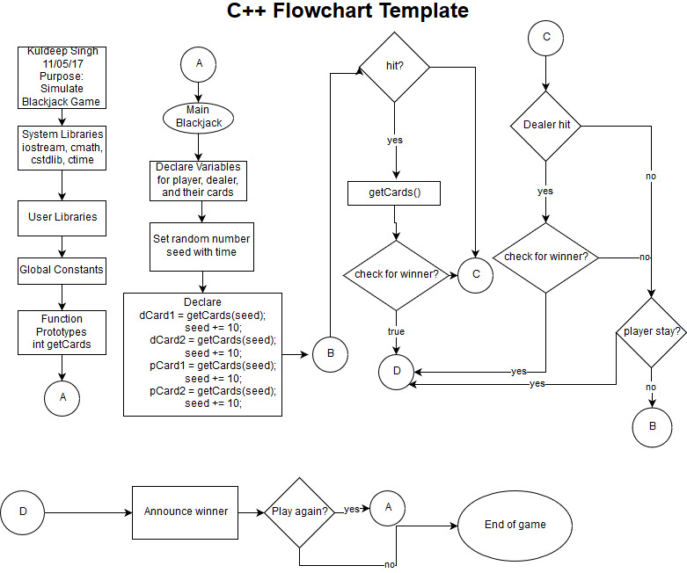

**Pseudo Code**

Welcome to Blackjack

Dealer’s has ? + card2

Player has card1 + card2 = total

If (dealer == 21 && player != 21)

Dealer wins

Else if (player ==21 && dealer != 21)

Player wins

Else if (player == 21 && dealer ==21)

Game tied

Else

Do you want a hit? Y or N

If hit

Player gets card

Check winner

Else

If (dealer total < 17)

Dealer gets card

Check winner

Loop back to “Do you want a hit? Y or N” statement

Reveal results

**C++ Constructs and Concepts Used**

|  |  |  |  |
| --- | --- | --- | --- |
| **Chapter** | **Section** | **Topic** | **Location** |
| 2 | 2 | Cout | cout << "Welcome to Blackjack! Game starting.." << endl;  cout<< endl << "The dealer has ? + " << dCard2 << endl;  cout<< "You have " << pCard1 << " + " << pCard2 << endl << endl;  cout<<"The dealer has " << dCard1 << " " << dCard2 << endl;  cout<<"The dealers wins." << endl;  cout<<"You have " << pCard1 << " " << pCard2 << endl;  cout<<"You win!" << endl;  cout << "You both have 21! Game tied!" << endl;  cout << "Would you like to hit? Y or N" << endl;  cout<<"That is not a valid choice. Please enter Y or N." << endl;  cout << "You got a " << newCard << endl << endl;;  cout<< "You have bust." << endl;  cout<<"It is the dealer's turn" << endl;  cout << "The dealer has decided to hit" << endl;  cout<< "The dealer has bust." << endl;  cout << "The dealer has decided to stay" << endl << endl;  cout << "Thank you for playing. Game ended." << endl; |
|  | 3 | Libraries | Iostream, cstdlib, ctime |
|  | 4 | Varaibles/Literals | dealer, dCard1, dCard2,  player, pCard1, pCard2,  turn, seed, choice, validChoice  gameContinue, turns, c |
|  | 5 | Identifiers | dealer, dCard1, dCard2,  player, pCard1, pCard2,  turn, seed, choice, validChoice  gameContinue, turns, c |
|  | 6 | Integers | dealer, dCard1, dCard2,  player, pCard1, pCard2,  c, seed(unsigned) |
|  | 7 | Characters | choice |
|  | 8 | Strings | none |
|  | 9 | Floats | none |
|  | 10 | Bools | validChoice, gameContinue, turns |
|  | 12 | Variables 7 characters or less | dealer, dCard1, dCard2,  player, pCard1, pCard2,  turns, seed, choice, turns, c |
|  | 14 | Arithmetic Operators |  |
|  | 15 | Comments | Used throughout the whole program |
|  | 16 | Named Constants | none |
|  | 17 | Programming Style | endl;  {} |
|  |  |  |  |
| 3 | 1 | Cin | cin>>choice |
|  | 2 | Math Expression | seed += 10  seed += 20  dealer = dCard1 + dCard2  player = pCard1 + pCard2 |
|  | 5 | Type Casting | none |
|  | 7 | Formatting output | Formatted to have extra spaces between output, separation between player and dealer turns, different lines for scores and winner declarations |
|  | 8 | Strings | none |
|  | 9 | Math Library | ctime |
|  |  |  |  |
| 4 | 1 | Relational Operators | ==  !=  >  < |
|  | 2 | If | if(choice == 'y' || choice == 'Y'){}  if(turn == 1){}  if(turn == 2){} |
|  | 4 | If-else | if(dealer == 21 && player!= 21){  else{}  if(turn == 0){}  else{}  if(dealer < 17){}  else |
|  | 5 | Nesting | Nested while loops  Nested if statements |
|  | 6 | If-else-if | if(dealer == 21 && player!= 21){}  else if(player == 21 && dealer != 21){}  else if(player == 21 && dealer == 21)  if(player > 21){}  else if(player == 21){} |
|  | 8 | Logical Operators | &&  || |
|  | 11 | Validating user Input | if(choice == 'y' || choice == 'Y' ||  choice == 'n' || choice == 'N')  validChoice = true;  else{  cout<<"That is not a valid choice. Please enter Y or N." << endl;  validChoice = false; |
|  | 13 | Conditional Operator | none |
|  | 14 | Switch | none |
|  |  |  |  |
| 5 | 1 | Increment/Decrement | seed += 10  seed += 20  player += newCard  dealer += newCard |
|  | 2 | While | while(gameContinue){}  while(turns){} |
|  | 5 | Do-While | do{}  while (validChoice == false); |
|  | 6 | For Loop | none |
|  | 11 | Files input/output both | none |

**Reference**

1. Textbook
2. [www.cplusplus.com](http://www.cplusplus.com)

**Program**

//System Libraries

#include <iostream> //Input/Output Stream Library

#include <cstdlib>

#include <ctime>

using namespace std; //Standard Name-space under which System Libraries reside

//User Libraries

//Global Consumer - not variables only Math/Science/Conversion constants

//Function Prototypes

int getCards(unsigned int);

//Execution Begins here:

int main(int argc, char** argv) {

//Declare Variables

int dealer, dCard1, dCard2;

int player, pCard1, pCard2;

int turn; //turn 0 is players turn, turn 1 is dealers turn, turn 2 for end

unsigned int seed;

char choice;

bool validChoice, gameContinue, turns;

//Initialize Variables

gameContinue = true;

turns = true;

seed = time(NULL);

cout << "Welcome to Blackjack! Game starting.." << endl;

while(gameContinue){

turn = 0;

turns = true;

//deal cards out to player and dealer

dCard1 = getCards(seed);

seed += 10;

dCard2 = getCards(seed);

seed += 10;

pCard1 = getCards(seed);

seed += 10;

pCard2 = getCards(seed);

seed += 10;

//get total values for player and dealer

dealer = dCard1 + dCard2;

player = pCard1 + pCard2;

cout<< endl << "The dealer has ? + " << dCard2 << endl;

cout<< "You have " << pCard1 << " + " << pCard2 << endl << endl;

if(dealer == 21 && player!= 21){

cout<<"The dealer has " << dCard1 << " " << dCard2 << endl;

cout<<"The dealers wins." << endl;

}

else if(player == 21 && dealer != 21){

cout<<"You have " << pCard1 << " " << pCard2 << endl;

cout<<"You win!" << endl;

}

else if(player == 21 && dealer == 21)

cout << "You both have 21! Game tied!" << endl;

else{

while(turns){

if(turn == 0){

seed+= 10;

do{

cout << "Would you like to hit? Y or N" << endl;

cin >> choice;

if(choice == 'y' || choice == 'Y' ||

choice == 'n' || choice == 'N')

validChoice = true;

else{

cout<<"That is not a valid choice. "

"Please enter Y or N." << endl;

validChoice = false;

}

} while(validChoice == false);

if(choice == 'y' || choice == 'Y'){

int newCard = getCards(seed);

cout << "You got a " << newCard << endl << endl;;

player += newCard;

if(player > 21){

cout<< "You have bust." << endl;

turn = 2;

continue;

}

else if(player == 21){

turn = 2;

continue;

}

}

turn = 1;

}

if(turn == 1){

seed += 20;

cout<<"It is the dealer's turn" << endl;

if(dealer < 17){

cout << "The dealer has decided to hit" << endl;

int newCard = getCards(seed);

cout << "Dealer got " << newCard << endl << endl;

dealer += newCard;

if(dealer > 21){

cout<< "The dealer has bust." << endl;

turn = 2;

continue;

}

else if(dealer == 21){

turn = 2;

continue;

}

}

else

cout << "The dealer has decided to stay" << endl << endl;

if(choice == 'n' || choice == 'N')

turn = 2;

else

turn = 0;

}

if(turn == 2){

cout << "The dealer has " << dealer << endl;

cout << "You have " << player << endl;

if(player > 21)

cout << "The dealer wins." << endl;

else if (dealer > 21)

cout << "You win!" << endl;

else if(dealer > player)

cout << "The dealer wins." << endl;

else if (player > dealer)

cout << "You win!" << endl;

else

cout << "You have both tied!" << endl;

do{

cout << "Would you like to play again? Y or N" << endl;

cin >> choice;

if(choice == 'y' || choice == 'Y'){

gameContinue = true;

turns = false;

validChoice = true;

}

else if(choice == 'n' || choice == 'N'){

gameContinue = false;

turns = false;

validChoice = true;

}

else{

cout<<"That is not a valid choice. "

"Please enter Y or N." << endl;

validChoice = false;

}

} while(validChoice == false);

}

}

}

}

//Input Data/Variables

//Process or map the inputs to the outputs

//Display/Output all pertinent variables

cout << "Thank you for playing. Game ended." << endl;

//Exit the program

return 0;

}

int getCards(unsigned int seed){

srand (seed);

int c = rand() % 13 + 1;

if(c > 10)

c = 10;

return c;

}